EXPERIMENT 3

Aim: To implement Multivariate Linear Regression
Theory :

- Multivariate Linear Regression Concept
Multivariate Linear Regression (also known as Multiple Linear Regression) is a supervised learning algorithm used to model the linear relationship between two or more independent predictor features ($X_1, X_2, \dots, X_n$) and a single continuous target variable ($Y$). Unlike Simple Linear Regression, which relies on only one independent variable, Multivariate Linear Regression accounts for multiple factors simultaneously to predict an outcome.
In the context of predicting student performance, a student's final score depends on several factors—such as study hours, class attendance, previous grades, and completed assignments—rather than just a single attribute.

- Multivariate Linear Regression Equation
The mathematical representation of Multivariate Linear Regression is given by:
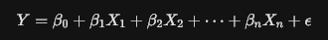

In vector/matrix form:


Gradient Descent:
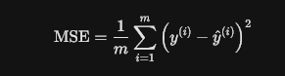

Steps to Implement Multivariate Linear Regression
- Data Collection & Loading: Load the dataset (student_performance_200.csv) containing the necessary input features and target variable.
- Data Preprocessing & Inspection: Check for missing values, inspect data types, handle outliers, and perform descriptive statistics.
- Feature and Target Selection: Define feature matrix $X$ (Study Hours, Attendance, Previous Grades, Assignments Completed) and target vector $y$ (Final Exam Score).
- Data Splitting: Split the dataset into training set (e.g., 80%) to fit the model and testing set (e.g., 20%) to evaluate performance on unseen data.
- Model Initialization & Training: Train a Linear Regression model using Ordinary Least Squares (OLS) on the training set to estimate parameters $\beta_0, \beta_1, \dots, \beta_n$.
- Prediction: Use the trained model to predict final exam scores on the test set.
- Model Evaluation: Evaluate performance using metrics like Mean Squared Error (MSE), Root Mean Squared Error (RMSE), and $R^2$ Score (Coefficient of Determination).
Implementation
- Dataset Name: student_performance_200.csv
- Source Location: Local File System / Workspace Directory (containing 200 student records)
- Application Chosen: 2. Student Performance Prediction
  - Inputs: Study Hours, Attendance (%), Previous Grades, Assignments Completed
  - Prediction: Final Exam Score

Code :
import pandas as pd
import matplotlib.pyplot as plt
from sklearn.model_selection import train_test_split
from sklearn.linear_model import LinearRegression
from sklearn.metrics import mean_absolute_error, mean_squared_error, r2_score
data = pd.read_csv("student_performance_200.csv")
print("\n========== STUDENT PERFORMANCE DATASET ==========\n")
print(data.head())
X = data[[
"StudyHours",
"Attendance",
"PreviousGrades",
"AssignmentsCompleted"
]]
y = data["FinalScore"]
X_train, X_test, y_train, y_test = train_test_split(
X,
y,
test_size=0.20,
random_state=42
)
print("\nTraining Data Size :", len(X_train))
print("Testing Data Size :", len(X_test))
model = LinearRegression()
model.fit(X_train, y_train)
print("\nModel Trained Successfully!")
y_pred = model.predict(X_test)
results = pd.DataFrame({
"Actual Score": y_test.values,
"Predicted Score": y_pred.round(2)
})
print("\n========== ACTUAL VS PREDICTED ==========\n")
print(results)
mae = mean_absolute_error(y_test, y_pred)
mse = mean_squared_error(y_test, y_pred)
rmse = mse ** 0.5
r2 = r2_score(y_test, y_pred)
print("\n========== MODEL EVALUATION ==========\n")
print("Mean Absolute Error (MAE):", round(mae, 2))
print("Mean Squared Error (MSE):", round(mse, 2))
print("Root Mean Squared Error (RMSE):", round(rmse, 2))
print("R² Score:", round(r2, 4))
print("\n========== REGRESSION COEFFICIENTS ==========\n")
coefficients = pd.DataFrame({
"Feature": X.columns,
"Coefficient": model.coef_
})
print(coefficients)
print("\nIntercept (Constant):", round(model.intercept_, 2))
print("\n========== REGRESSION EQUATION ==========\n")
print(
f"FinalScore = {model.intercept_:.2f}"
f" + ({model.coef_[0]:.2f} × StudyHours)"
f" + ({model.coef_[1]:.2f} × Attendance)"
f" + ({model.coef_[2]:.2f} × PreviousGrades)"
f" + ({model.coef_[3]:.2f} × AssignmentsCompleted)"
)
print("\n========== SAMPLE STUDENT PREDICTION ==========\n")
sample_student = X_test.iloc[[0]]
predicted_score = model.predict(sample_student)
print("Student Details:\n")
print(sample_student)
print("\nPredicted Final Score :", round(predicted_score[0], 2))
print("Actual Final Score :", y_test.iloc[0])
plt.figure(figsize=(8,6))
plt.scatter(y_test, y_pred)
plt.plot(
[y_test.min(), y_test.max()],
[y_test.min(), y_test.max()],
'r--',
linewidth=2
)
plt.title("Actual vs Predicted Final Scores")
plt.xlabel("Actual Final Score")
plt.ylabel("Predicted Final Score")
plt.grid(True)
plt.show()

OUTPUT :
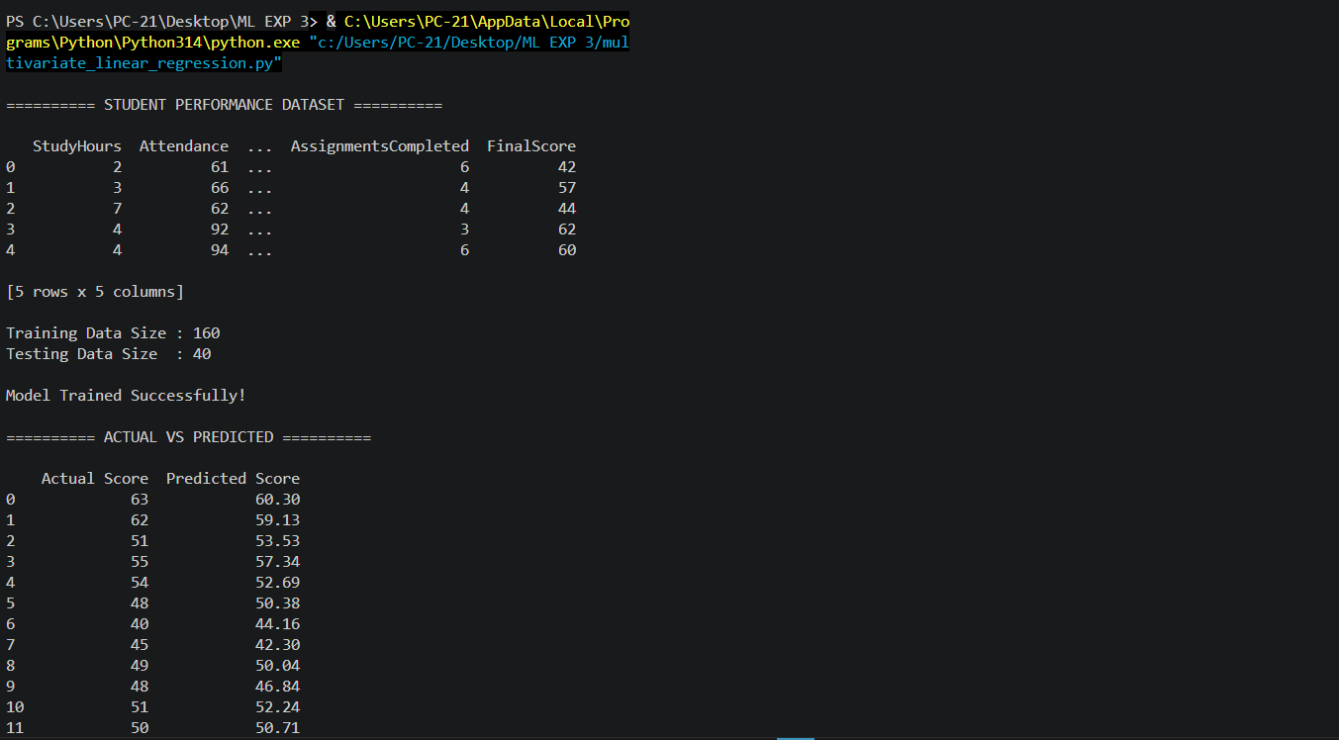
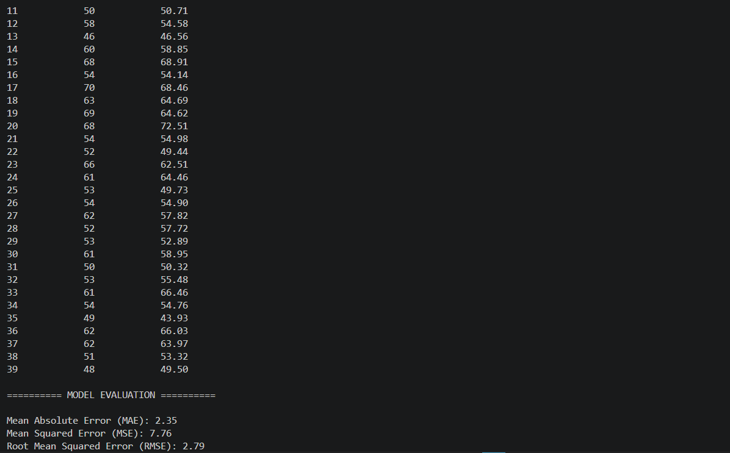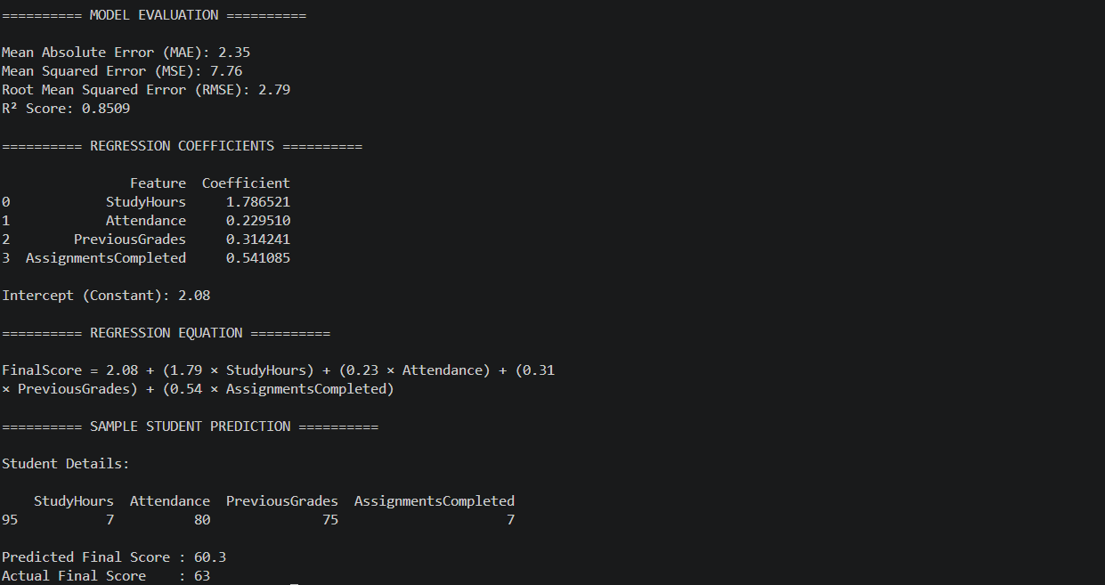
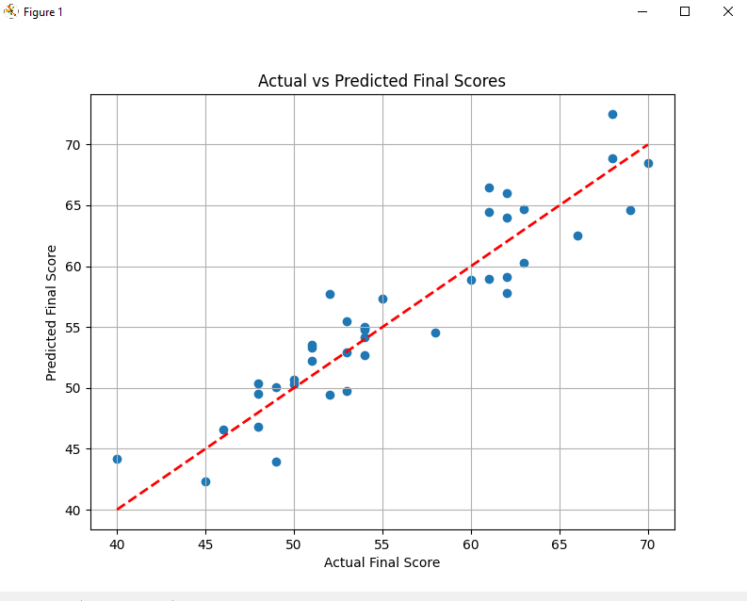

Conclusion
Multivariate Linear Regression was successfully implemented using the student_performance_200.csv dataset to predict students' final exam scores based on study hours, attendance, previous grades, and completed assignments. The regression parameters were calculated, and the model's performance was evaluated using standard evaluation metrics ($R^2$ score and RMSE). The results demonstrate that incorporating multiple input features provides a more comprehensive and accurate prediction model compared to using a single attribute.

Post-Lab Question Answers
1. Differentiate between Simple Linear Regression and Multivariate Linear Regression.

Feature / Aspect | Simple Linear Regression | Multivariate (Multiple) Linear Regression
Number of Independent Variables ($X$) | Exactly one predictor variable ($X_1$). | Two or more predictor variables ($X_1, X_2, \dots, X_n$).
Equation | $Y = \beta_0 + \beta_1 X_1 + \epsilon$ | $Y = \beta_0 + \beta_1 X_1 + \beta_2 X_2 + \dots + \beta_n X_n + \epsilon$
Geometric Representation | A straight line in a 2D space. | A plane (3D) or hyperplane ($N$-dimensional space).
Complexity | Simpler to compute, interpret, and visualize. | More complex; requires checks for multicollinearity.
Example | Predicting final exam score based only on study hours. | Predicting final exam score based on study hours, attendance, previous grades, and assignments.

2. What is the purpose of splitting data into training and testing sets?
The primary purposes of splitting data into training and testing sets are:
- Evaluating Generalization Performance: It allows us to measure how well the model generalizes and performs on unseen data, rather than just memorizing the data it was trained on.
- Preventing Overfitting: Training and evaluating a model on the exact same data leads to overfitting—where the model performs exceptionally well on training data but fails terribly on real-world test data.
- Unbiased Performance Metrics: Splitting ensures an objective, unbiased evaluation of performance metrics such as Mean Squared Error (MSE), Root Mean Squared Error (RMSE), and $R^2$ Score.

